Gortnahoe N.S.

Gortnahoe,
Thurles,
Co.Tipperary

Telephone: 056- 8834390
Email: info@gortnahoens.ie
Roll Number: 17580P

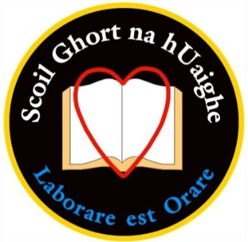

Dear Parent/s,

Derek’s Retirement
I would like to thank you all most sincerely for the generous donations made towards Derek’s retirement gift and your presence on the night. Thanks also to those who made sandwiches, cakes etc. and who helped out in any way. The children were excellently behaved and gave a great performance in the hall and the church. Thanks to all our teachers and staff for their work on the night. A special thanks to Múinteoir Thérese for organising the night, and to Múinteoir Ciara, Múinteoir Annie and Múinteoir Katherine for the wonderful work with the music. I would also like to thank PJ Ryan for the great work he did in organising the parents to help out with the night. It was great to see such a strong parents’ presence and hopefully we can work together to get an active parent’s association up and running again in January.

Fundraising
We raised €570 from our Cake Sale, and the bags are starting to come in for our clothes collection which ends this Thursday. We’re very grateful for your continued support in helping us raise much needed funds for the school.

New Staff Members
We welcome Annie Hayes to our school, who will be teaching 4th class until the end of June. We also welcome Laura Quirke who has just joined our Special Ed. Team on a part-time basis until the end of June.

School Uniform
Please ensure your child has the full school uniform and school tracksuit. As per our policy, shoes are to be worn with the uniform and not runners. Please label your child’s uniform. From January onwards, there will be a Lost & Found section inside the entrance to the infant room.

Christmas Cards
No cards or gifts for Christmas or parties in general are to be distributed in school, at the school gate or on the school bus.

Running
Our running programme will finish this Wednesday. The children have made a great effort this term and we can really see their levels of fitness continuing to increase.

Familiarisation Night
Thanks to all who attended the familiarisation night and I hope you found it beneficial.

Communication
To maximise pupil/ teacher time and to avoid disruptions as much as possible, all appointments should be made with Imelda in the office.
Please note we are no longer using the pink slip for pupils who miss a day in school. Please write a note in your child’s diary explaining the reason or you can email the office explaining the absence. info@gortnahoens.ie

Enrolment Ceremony/ Ceremony of Light – Communion – Confirmation Dates
Well done to all involved in the Enrolment Ceremony and the Ceremony of Light in 2nd, 5th & 6th class.
First Confession is Tuesday, 28th of March.
First Holy Communion is Saturday, 20th of May
Confirmation is Tuesday, 28th of February.

U21 Hurlers
Congratulations to the club, management and panel of players who won the County U21 Final yesterday. It was brilliant to see so many past pupils involved and this will encourage all the younger boys and girls in our school to continue hurling and improving their skills.

School Closures
The school will be closed on Friday, February the 3rd to facilitate professional development training for the new Primary Language Curriculum.
School will close at 2.00 pm on 25/01/17 and the 10/05/17 to facilitate staff meetings.

Christmas Holidays
We close with a half day on Thursday the 22nd of December at 12.30. The school re-opens on Monday the 9th of January.

I would like to thank you all for your best wishes and support since taking over as principal and I look forward to your continued co-operation in the future.

Yours sincerely,

________________
David O’Dwyer
Principal

